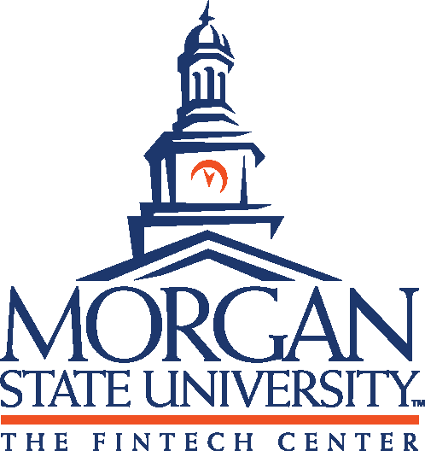

The Center for the Study of Blockchain and Financial Technology at Morgan State University is pleased to announce a competitive initiative to build awareness of and engagement with blockchain and FinTech at HBCUs.

The FinTech Center is offering ten (10) competitive innovation grants of $10,000 each for developing and implementing innovative educational activities and programs on HBCU campuses. Only one grant per university will be awarded; however, multiple proposals may be submitted. We are seeking creative ideas for capacity building in the areas of blockchain and FinTech geared to the current unique situation on your campus. The grant duration is from July 1 to December 7, 2020.

The FinTech Center will consider proposals for activities including, but not limited to, faculty workshops, programming with student-run blockchain clubs, opportunities for career exploration, and other extracurricular events. We are looking for creative and out-of-the-box thinking that impacts a large student body.

The Center encourages submissions from a wide variety of disciplines including but not limited to, the arts, law, sociology, accounting, computing, economics, engineering, sciences, entrepreneurship, finance, marketing, supply chain, health care, etc.

This grant does not include funding for new course development, course modifications, or research.

Each proposal must include:

I. Cover Page

- The principal investigator
- The project title
- A summary of the project
- An explanation of how the proposed activities will contribute to raising awareness and knowledge of Blockchain and FinTech among faculty and students
- A list of proposed activities to involve faculty and students from multiple disciplines

II. Letters of Support

- From your Provost or Dean who is familiar with the effort and willing to support the activities
- It would be appropriate and acceptable to request a letter from any additional organizations as well.
- These letters should be on the appropriate letterhead.

III. Narrative & Proposed Activities (4-6 pages)

- The impact that these activities will have on the University
- A description of partnerships necessary to make the program successful
- The beneficiaries of the work and its constituencies
- Expected outcomes and benefits including the projected numbers of students, faculty and/or other individuals who will be impacted
- A schedule describing the major activities to be carried out and the division of responsibilities for the different components of the project

IV. Budget

- Budgets are not to exceed $10,000.
- Your budget and budget narrative should include the anticipated expenses that your project will incur for the period of the grant.
- You should take a holistic approach when describing your budget and painting your proposed, financial picture.

V. Facilities

- A description of any space that would be used for this project and why it is important
- State whether the programs and activities will be implemented online, on-campus, or in another location.

VI. Evaluation

- Key evaluation points and measurable outcomes of your project
- A successful evaluation will highlight the most useful information about the project’s objectives and determine a methodological approach and data collection procedures.

Application Deadline Friday, June 5, 2020
Announcement of Awards Friday, June 12, 2020
The framework for implementation of the project is starting from July 1, 2020, until November 30, 2020. All activities must be completed by November 30th and an evaluation report must be submitted no later than December 7, 2020.
REFER YOUR COLLEAGUES HERE!

